Twinkle Twinkle Little Star

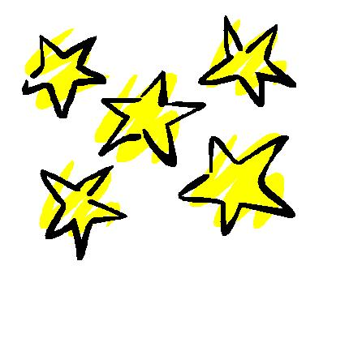
Twinkle, twinkle, little star,
How I wonder what you are.
Up above the world so high,
Like a diamond in the sky.
Twinkle, twinkle, little star,
How I wonder what you are!

