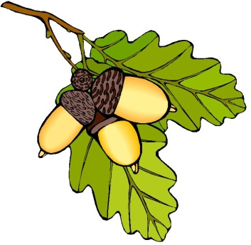
Uniform Order Form

Please return your completed order form and payment to the Acorn office.
BACS payment to: Acorn Playgroup and pre-school; Account Number - 80492663; Sort Code – 20-92-54 using your child’s name as a reference.

Ordered items are usually available within two weeks of receiving your completed application form and payment. Please note, each child will be issued with an Acorn book bag upon their start at Acorn, at no additional cost.

Child’s Name
Item | Age 2-3 |  | Age 3-4 | Age 5-6 | Price |  | Quantity | Total  Price
Acorn Bookbag |  |  |  |  | £5 |  |  | £
Red Acorn Polo Shirt |  |  |  |  | £7.50 |  |  | £
Red Acorn Sweatshirt |  |  |  |  | £8.50 |  |  | £
Total Payment £
Payment made  - Yes  - No |  | Payment made via Cash |  |  |  | Payment made via BACS

Name
Signature
Date

